Gross Pollutants Fact Sheet

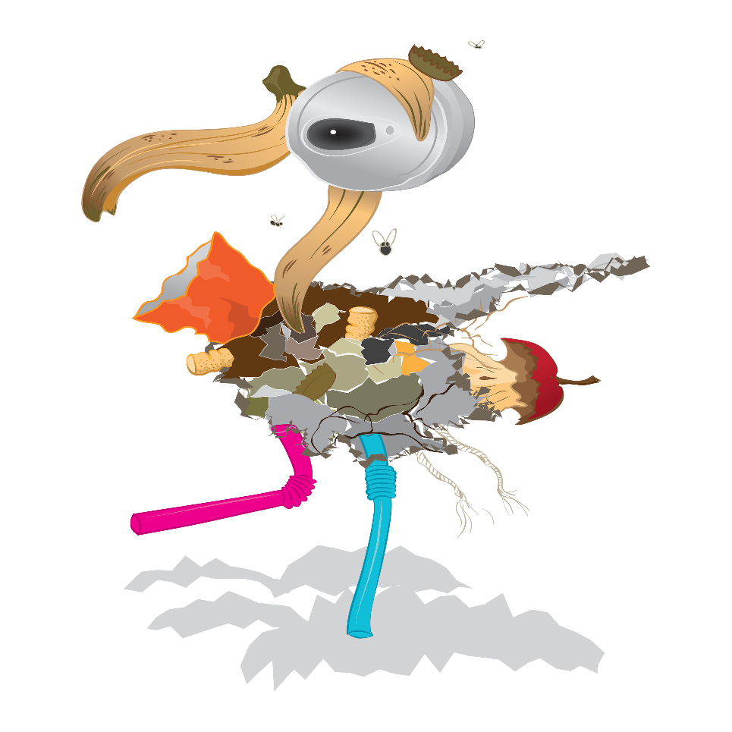

Gross pollutants are a major source of visual and physical pollution to water ways. Depending on the area the type of gross pollutants will change, an industrial area will likely contain polystyrene , cardboard wood chips while a shopping centre will likely have food wrappings and plastic bottles. Residential areas can contribute grass clippings, animal droppings or waste from renovations.

These pollutants can be extremely hazardous to marine creatures causing death. They can ensnare or be ingested by a variety of birds, fish or mammals causing trauma or death. Gross pollutants also carry nutrients into waterways and cause visual pollution. They degrade areas that they come into contact with and cause physical, biological and chemical impacts.

## What you can do

Recycling waste or placing it into rubbish bins is a excellent way of reducing this problem. Pick up one piece of litter each day to help keep this problem at bay

## Links references? Keep?

<http://www.goldcoast.qld.gov.au/gcplanningscheme_0509/attachments/policies/policy11/section_13_12_pretreatment.pdf>

<https://eprints.qut.edu.au/41517/2/41517.pdf>